Crypto Adaptive Payments Documentation:

To use the Crypto Adaptive Payment Plugin, you first have to install Three accompanying plugins:

1 GoUrl Bitcoin Payment Gateway & Paid Downloads & Membership (https://engb.wordpress.org/plugins/gourl-bitcoin-payment-gateway-paid-downloads-membership/)

Dokan Multivendor Plugin (https://wedevs.com/dokan/)

WooCommerce (https://woocommerce.com/)

Please note - The previous 3 plugins abide by their own Terms and Conditions, which are subject to change at their respective owners or admins will. Crypto Adaptive Payments take no responsibility for any issues, including (but not limited to) loss of income, due to any issues with the aforementioned plugins. Please contact their respective owners/admin directly to resolve any issues.

You can download these plugins from the [Wordpress Repository](https://en-gb.wordpress.org/plugins/). Dokan multivendor is a paid plugin and you can buy this from the above link.

Once you configure the aforementioned plugins, the next step is to go to the Coin Split website, <https://coinsplit.io>, and creating an account there. You will then need to add a payment scheme as outlined in the below image:

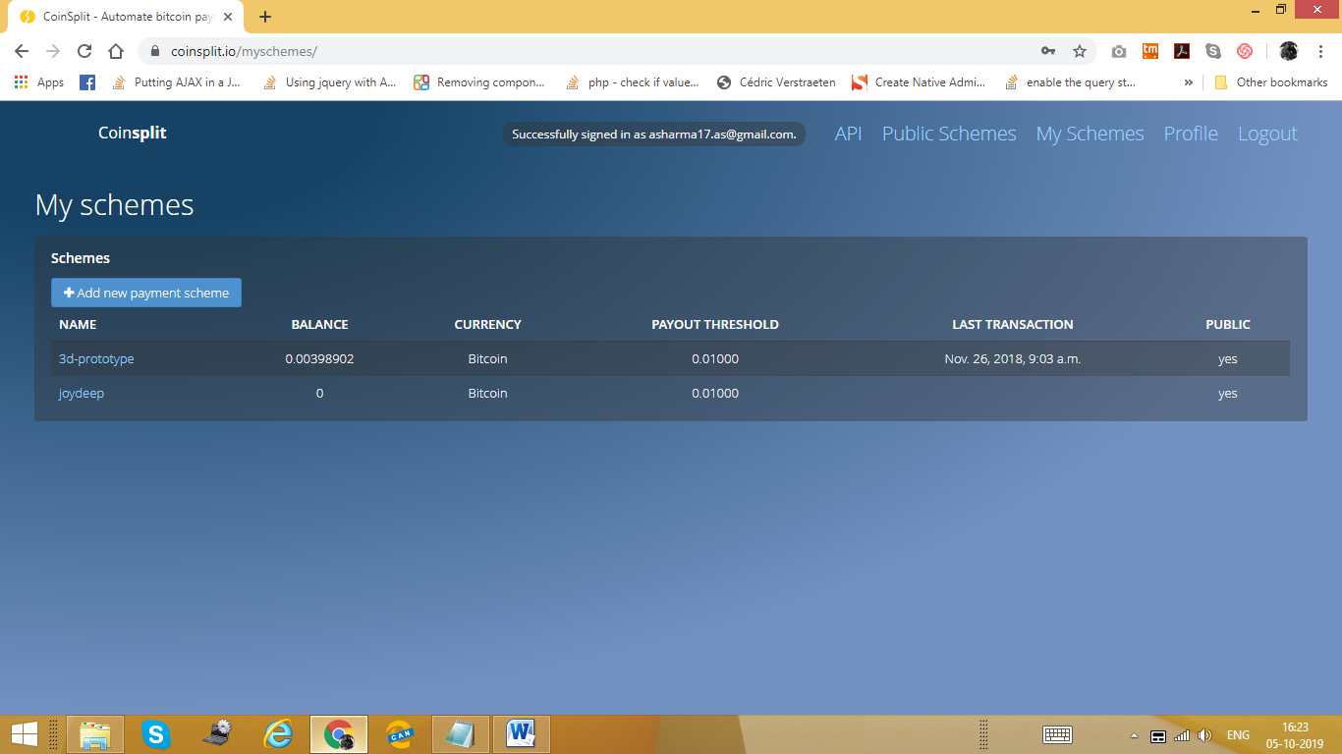

You will first need to name the payment scheme, apply a threshold to the scheme, and choose a Crypto Currency (Bitcoin, BTC, for now as this is the only Crypto Currency that Crypto Adaptive Payment is configured to).

Please continue to the next page.

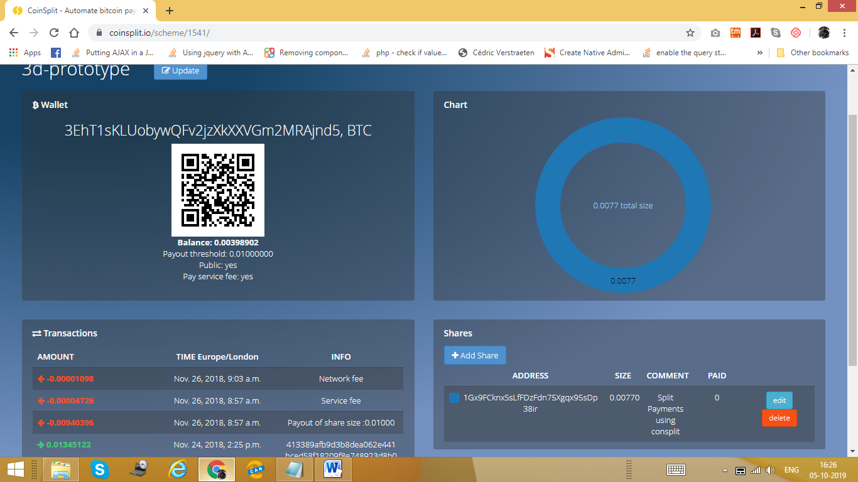

You will be provided with an External Wallet ID (an example of this is 3EhT1sKLUobywQFv2jzXkXXVGm2MRAjnd5, further outlined in the image above). Write this down and keep it safe as all of the Bitcoin Payments will be going to, and subsequently the shares will be leaving from, this wallet.

You will find that the URL contains the Scheme ID. For instance, if the URL is ‘<https://coinsplit.io/scheme/1541/>’, your scheme ID is the last line of numbers. In this case being ‘1541’. Do take note of this as well and keep it safe.

The next step is to retrieve the APR Authorization Key. For this, you will need to go to the ‘My Profile Section’, screen shot outlined below, and search for the API token. Again, do take note of this and keep it safe as you will need it for future steps.

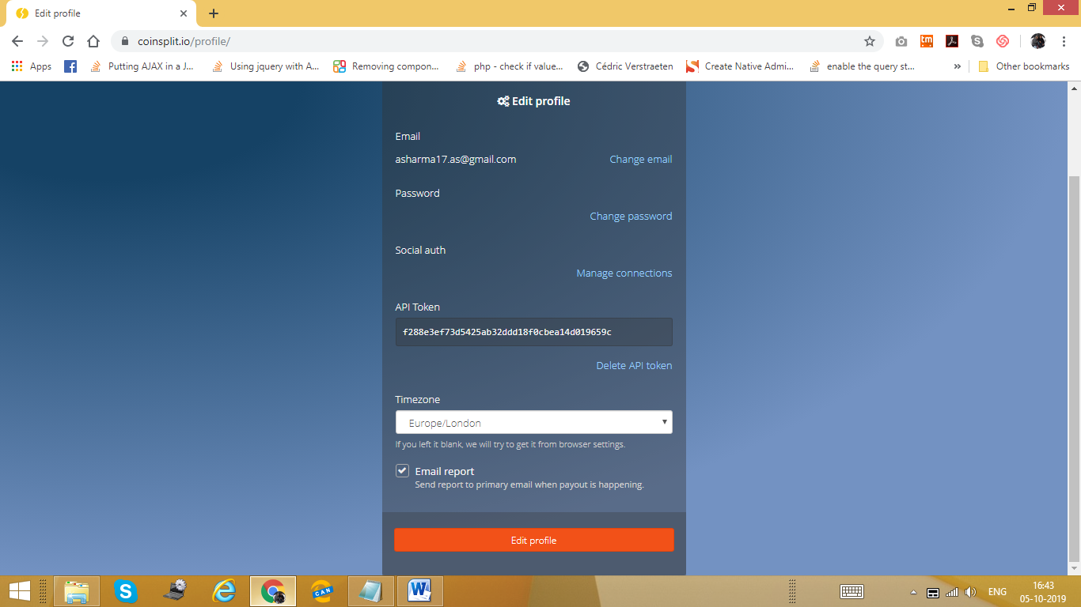

Now its time to create an account on GoURL (<https://gourl.io>). Once an account is created, you need to create a payment box as shown in the below screenshot.

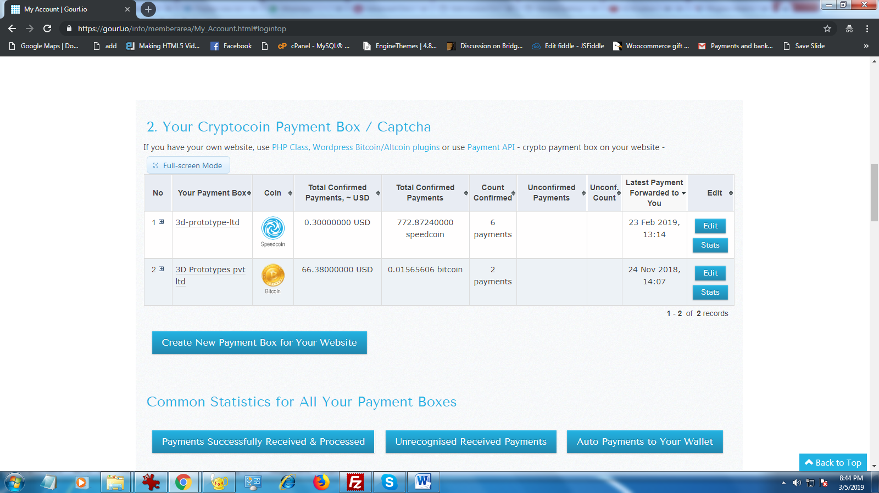

You remember earlier when we asked you to keep your External Wallet ID safe? Well you are going to need it to create a Payment Box so type that into the Your External Wallet Address field.

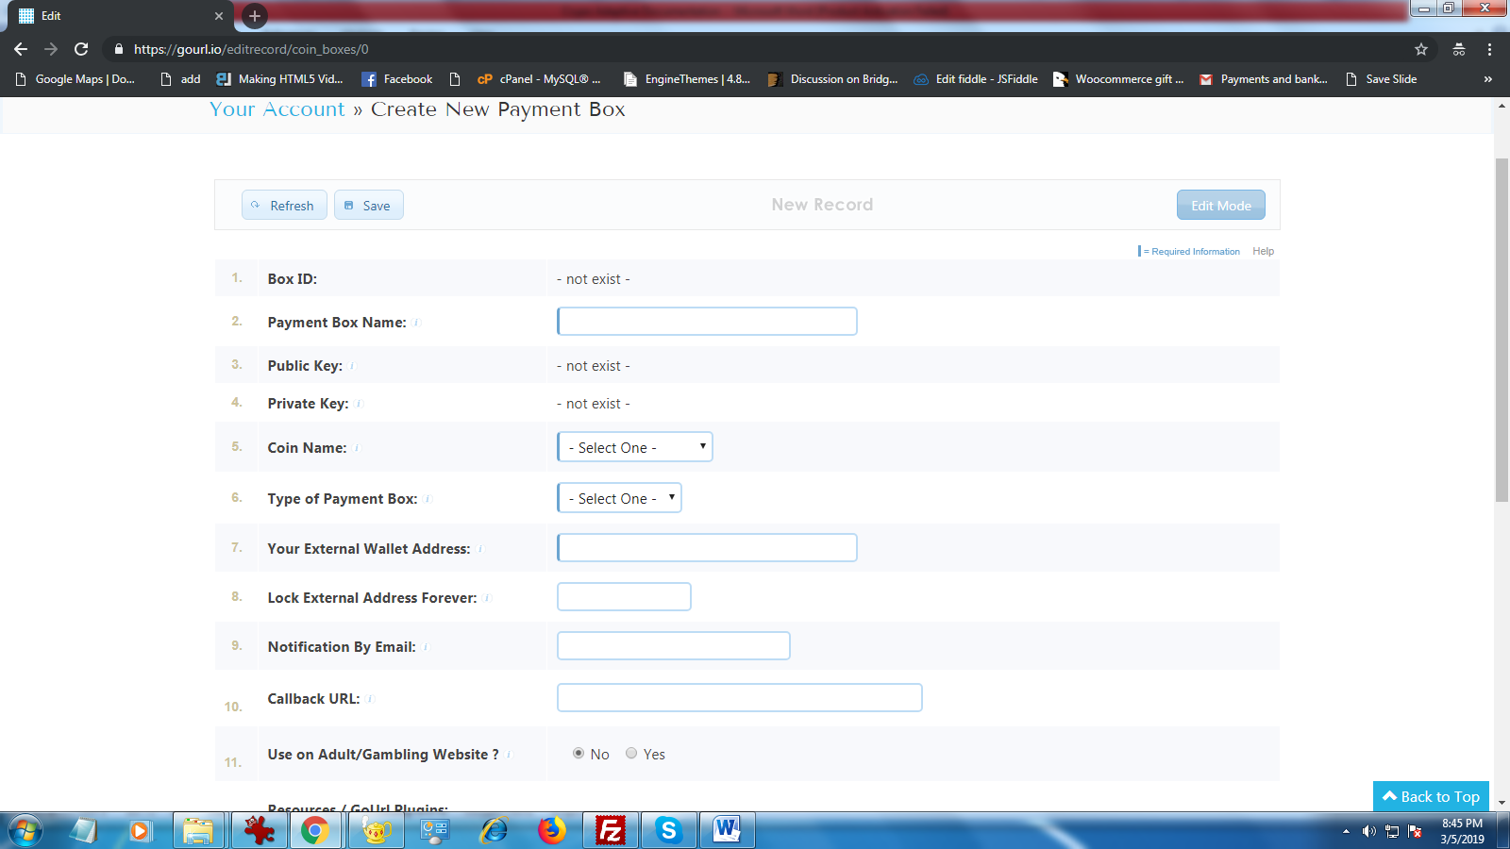

Once all the required fields are filled, go ahead and save the form and a Public Key and a Private Key are generated. Again, keep this information safe and handy.

Now log in to your Wordpress Dashboard, as the Administrator. Once in your dashboard, find the GoUrl Bitcoin subsection, as outlined below, and search for the CallBack URL (Again, as outlined in the image below. Do make a copy of this information, keep it safe and handy.

Now nip into the GoURL website and place this CallBack URL into the required field. Also now look for the section called Bitcoin Private Key and Public Key and input the previously obtained keys here.

Press save settings and the payment gateway should be ready.

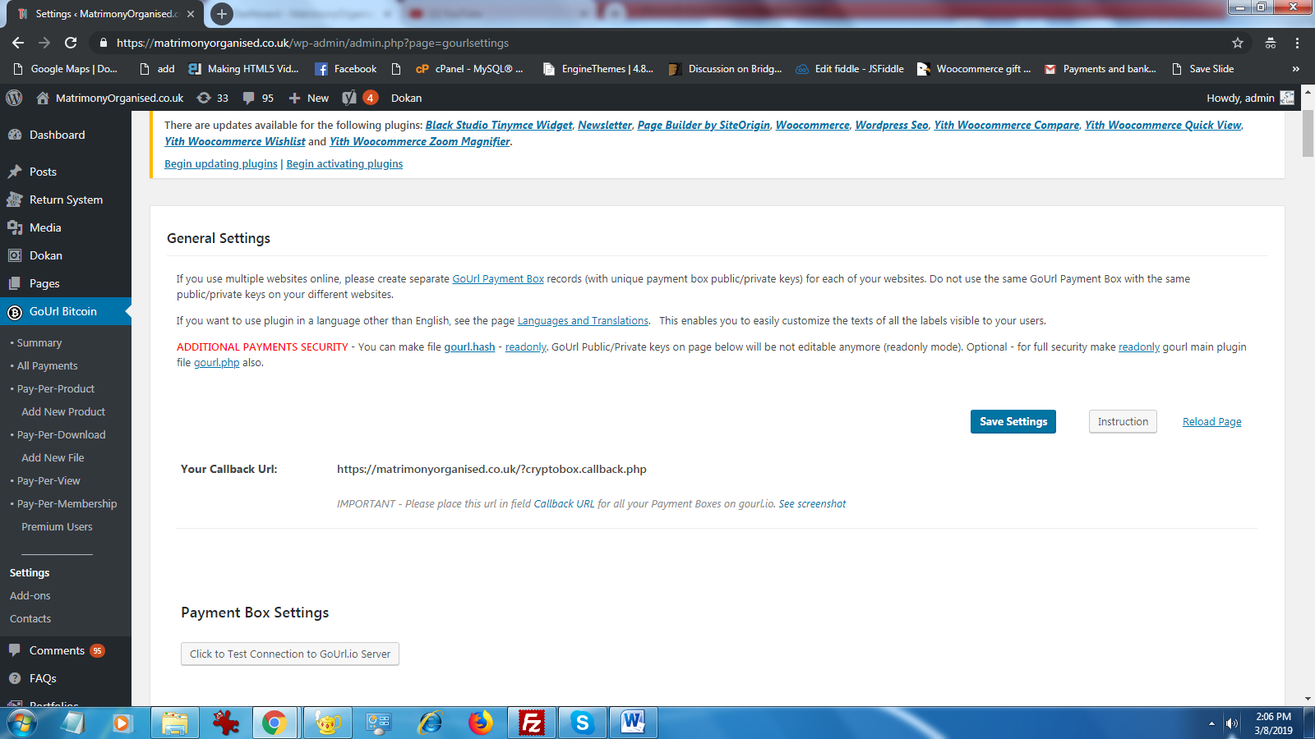

Once our plugin is installed, there will be a section in the backend called ‘BTC Settings’. Here is where you have to input the previously obtained Coinsplit Scheme ID, Authoriation API Key and you can further choose whether you would like the payment system to be ‘Normal’ or ‘Adaptive’ which will subsequently allow you to input the admin percentage. And the seller percentage will be calculated automatically by the system and will be forwarded to them via coinsplit.

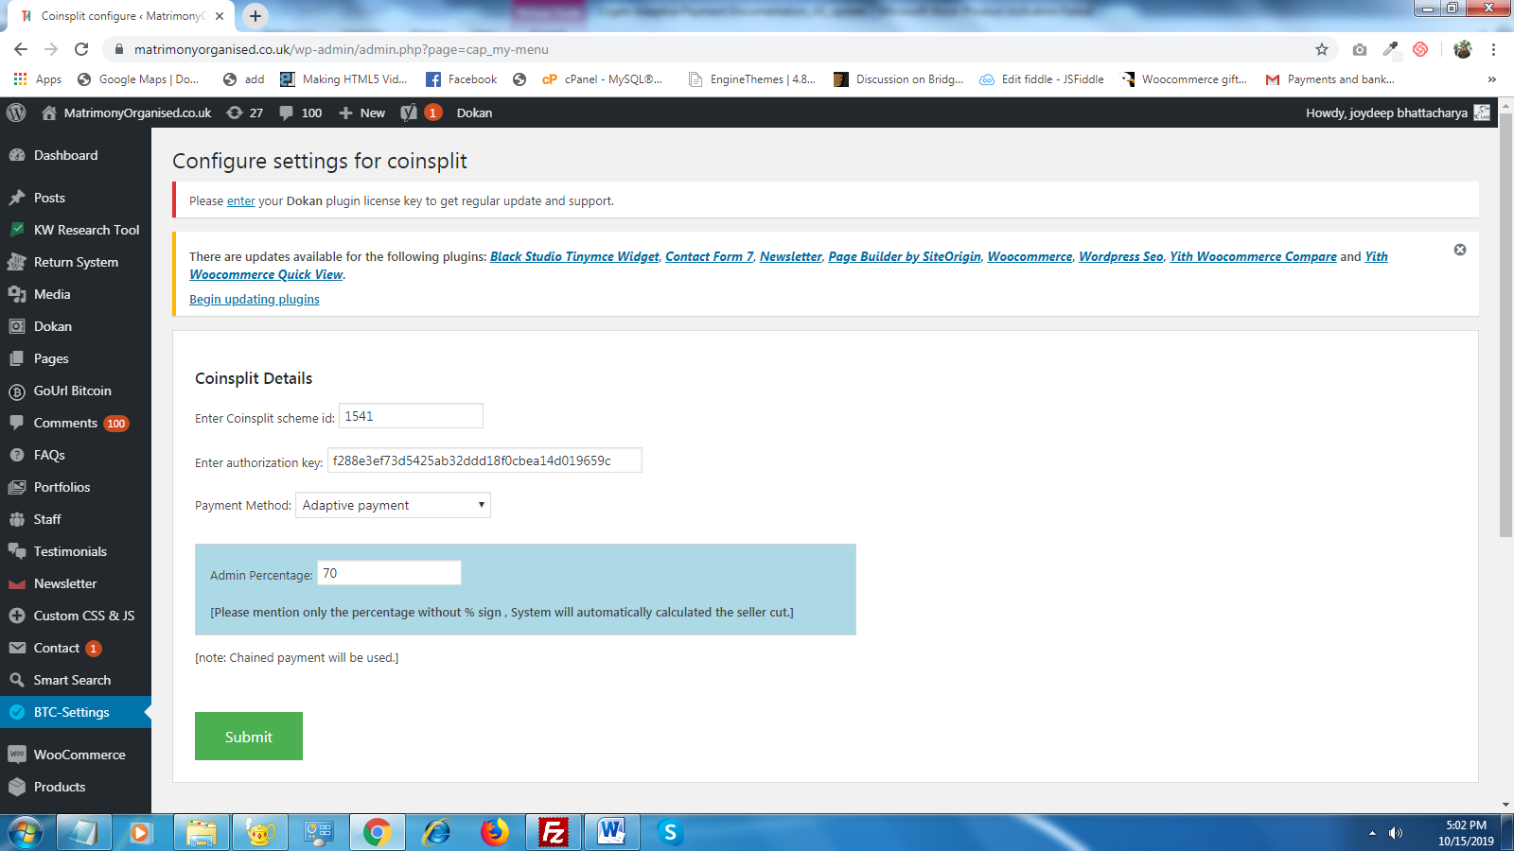

If you are using Dokan multivendor ,WooCommerce and Wordpress, the seller also has a dashboard. Now they will have a section called ‘Bitcoin Wallet ID’. Here is where they add their wallet ID for payment of their percentage of the sale. Please see image below

The system now has yours, Admin, and the sellers Bitcoin Wallet ID’s so you should be good to go. when an item is sold, your predetermined percentage of the final cost will go to the sellers BTC wallet and similarly, your predetermined percentage of the final cost will be deposited in yours.

